1. Visit the official Helm Release page on GitHub.

https://github.com/helm/helm/releases

2. Locate the Windows [amd64](https://phoenixnap.com/glossary/amd64) download link from the Installation platform list and select it to download.

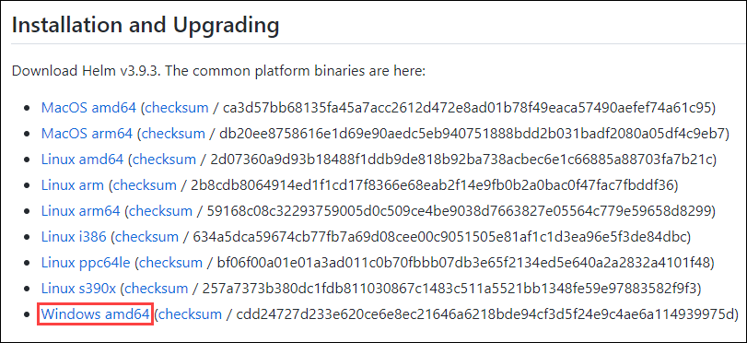

3. Extract the zip file. You will have these files inside the extracted folder.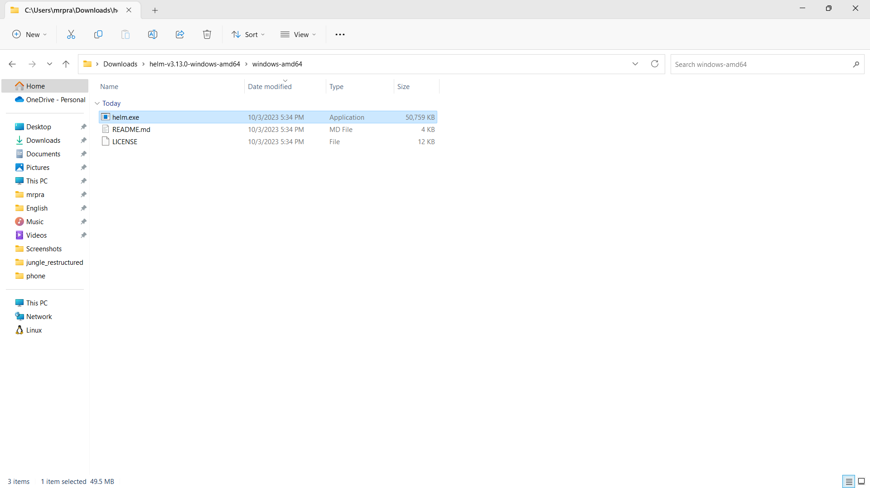

4. Create a folder called kubernetes on Desktop and copy extracted **helm.exe** to that folder.

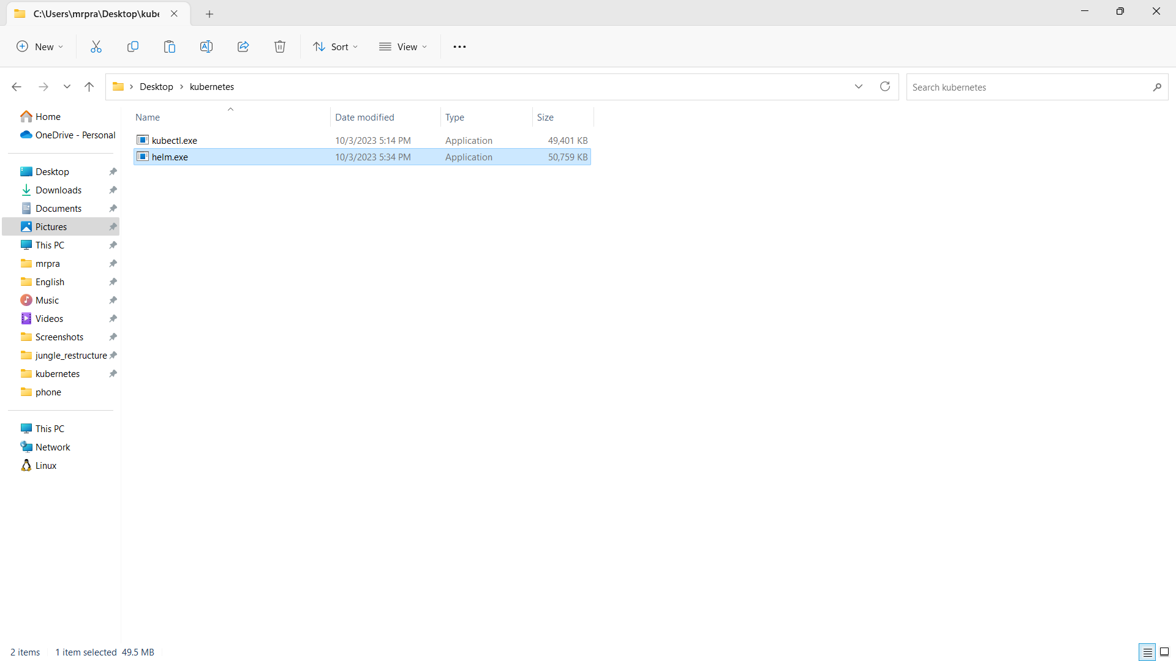

5.Now right click on this file, More Options>Properties. Then copy the Location of this file.

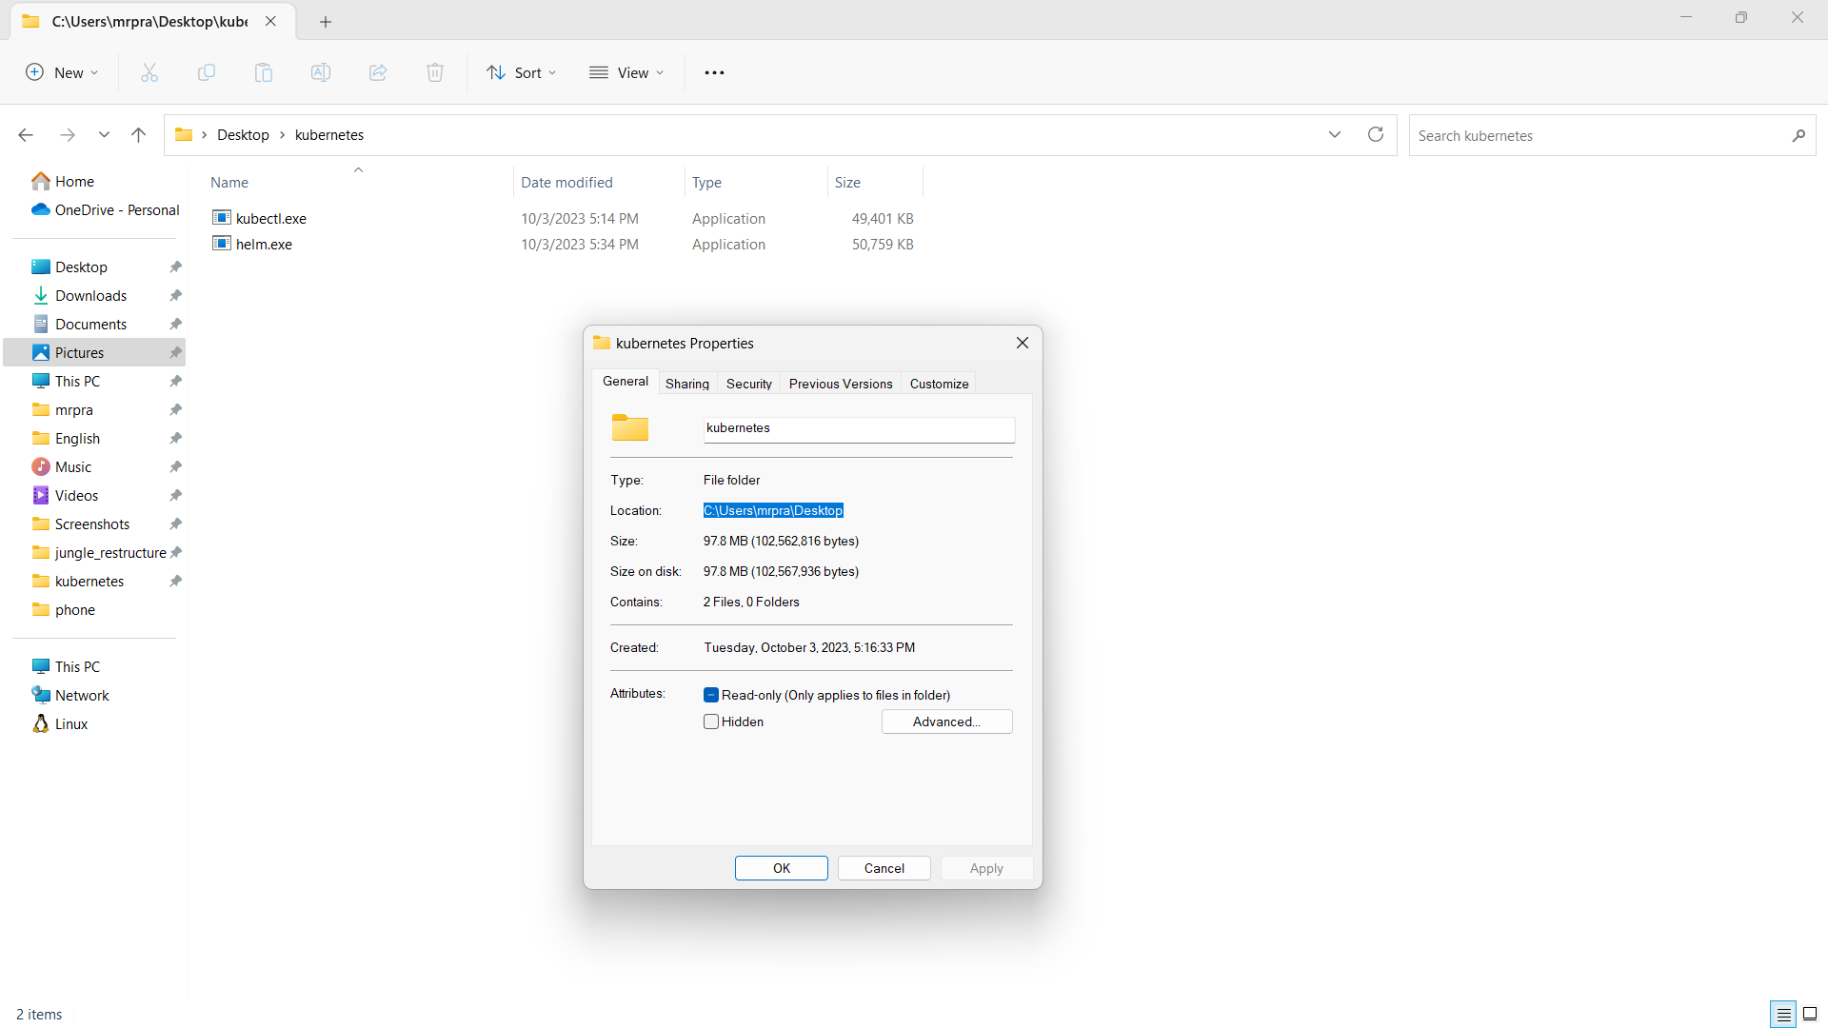

6. Now search for environment in the search box and open the first result.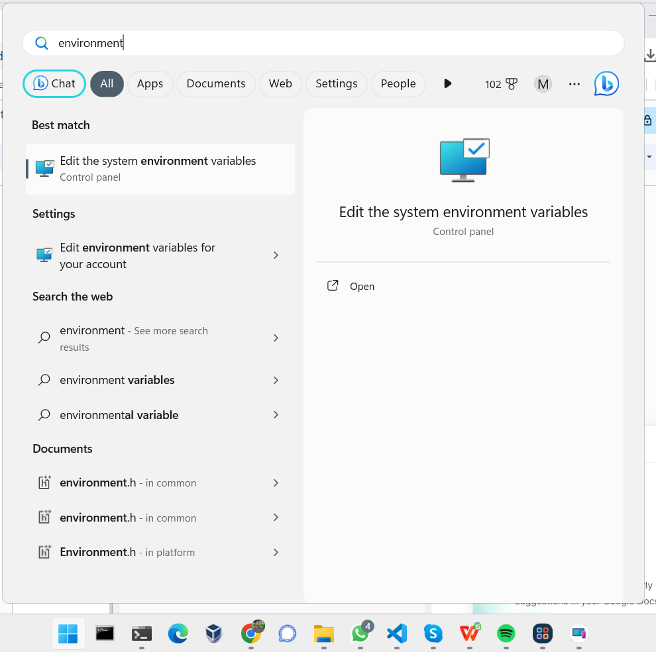

7.Now click on Environment Variables Again

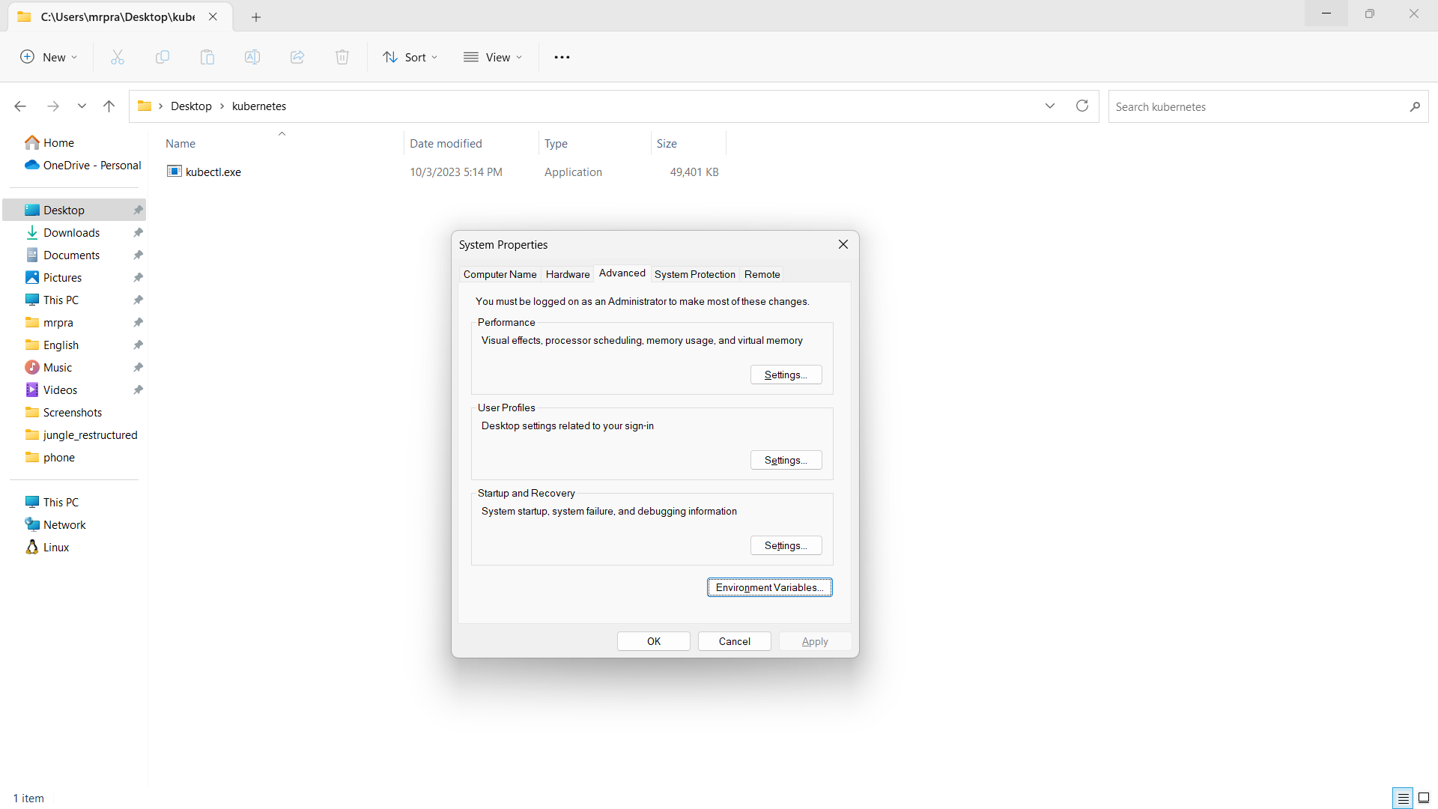

8. Select the **Path** variable and click on **EDIT**.

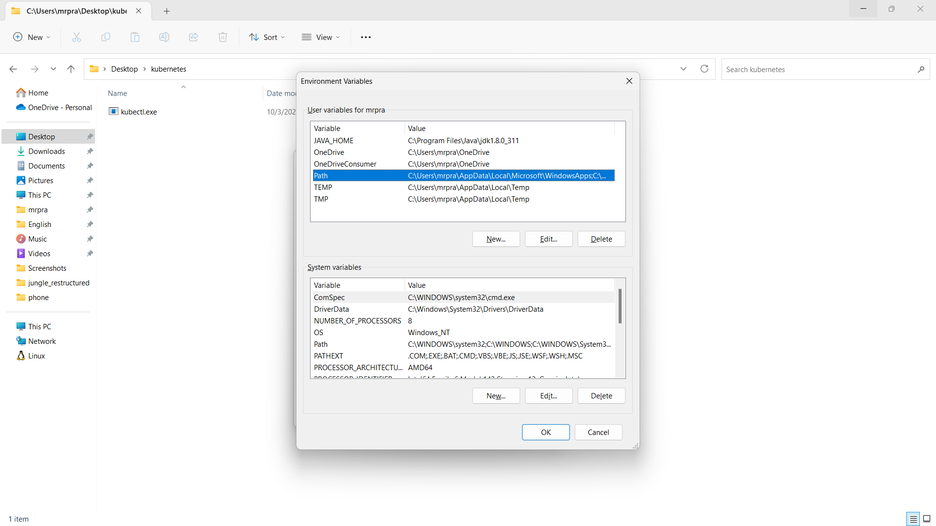

9. Now click on **NEW** and paste the Location of helm.exe

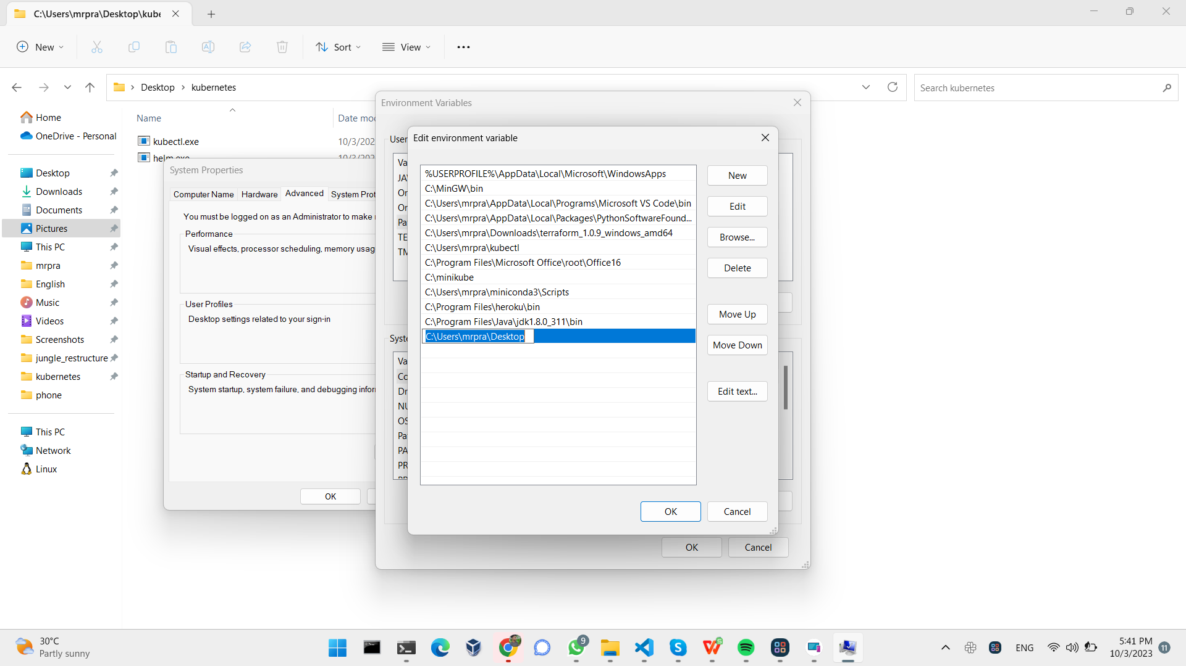  
10. Click OK>OK>Apply.

11. Now open command prompt and you can run

$ helm

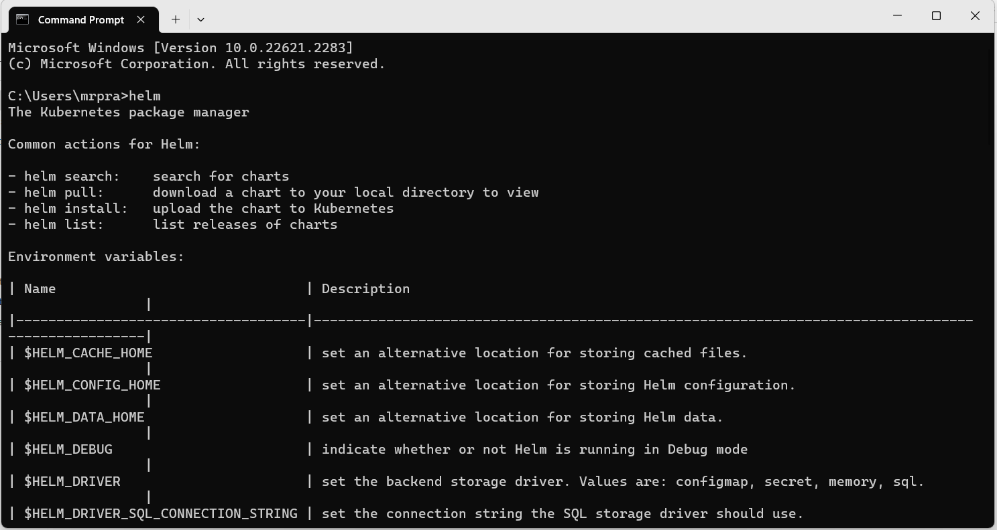

12. Installation of helm is successfully done.